Part Number: PT908-11175-02 (Gas) PT908-11176-02 (Hybrid)

Kit Contents
Item # | Quantity Reqd. | Description
1 | 1 | Cargo Tray
2
3
Hardware Bag Contents
Item # | Quantity Reqd. | Description
1
2
3
Additional Items Required For Installation
Item # | Quantity Reqd. | Description
1
2
3
Conflicts
None
Recommended Tools
Personal & Vehicle Protection | Notes
Cover or blanket
Special Tools | Notes
None
Installation Tools | Notes
None
Special Chemicals | Notes
None
General Applicability
All LC/LCh models (check part number)
Recommended Sequence of Application
Item # | Accessory
1 | Cargo Tray
2 | Cargo Net
3
*Mandatory
Vehicle Service Parts (may be required for reassembly)
Item # | Quantity Reqd. | Description
1
2
3
Legend
STOP: Damage to the vehicle may occur. Do not proceed until process has been complied with.
OPERATOR SAFETY: Use caution to avoid risk of injury.
CAUTION: A process that must be carefully observed in order to reduce the risk of damage to the accessory/vehicle and to ensure a quality installation.
TOOLS & EQUIPMENT: Used in Figures calls out the specific tools and equipment recommended for this process.
REVISION MARK: This mark highlights a change in installation with respect to previous issue.
SAFETY TORQUE: This mark indicates that torque is related to safety.

Care must be taken when installing this accessory to ensure damage does not occur to the vehicle. The installation of this accessory should follow approved guidelines to ensure a quality installation.

These guidelines can be found in the "Accessory Installation Practices" document.

This document covers such items as:-
- Vehicle Protection (use of covers and blankets, cleaning chemicals, etc.).
- Safety (eye protection, rechecking torque procedure, etc.).
- Vehicle Disassembly/Reassembly (panel removal, part storage, etc.).
- Electrical Component Disassembly/Reassembly (battery disconnection, connector removal, etc.).

Please see your Lexus dealer for a copy of this document.

Prepare for the Installation.
  - Open the package and check the part for damage and kit contents.
  - Remove any stored items and debris from the trunk area.
  - Place vehicle protection over the trunk opening & rear bumper.

Install the Cargo Tray.
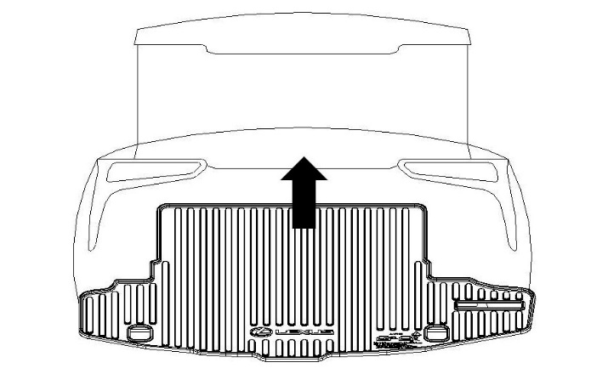
  - Place the Cargo Tray in the trunk area with the logo towards the rear of the vehicle and facing up (Fig. 2-1).
Fig. 2-1

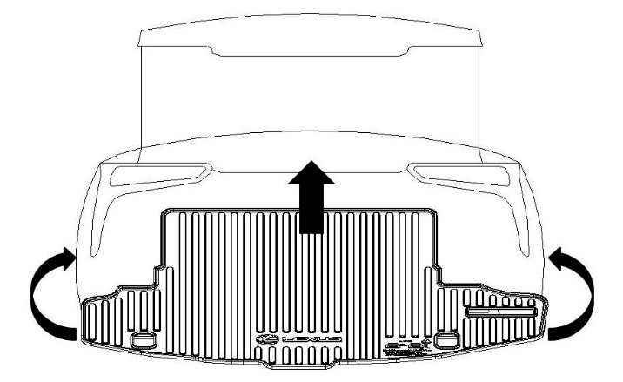
  - Grasp the tray by the sides and fold it up and inward sufficiently to slide it into the rear compartment (Fig. 2-2).
Fig. 2-2
  - After installing the tray, ensure all of the edges are pushed down against the floor.

Complete the Installation.
  - Remove the vehicle protection.
  - Close the trunk lid.

Accessory Function Checks
Correct part number has been installed

Vehicle Function Checks

Verify part number on package

Vehicle Appearance Check
After accessory installation and removal of protective cover(s), perform a visual inspection.

Ensure no damage (including scuffs and scratches) was caused during the installation process.
(For PPO installations, refer to TMS Accessory Quality Shipping Standard.)

